RECOVERY TANK ASM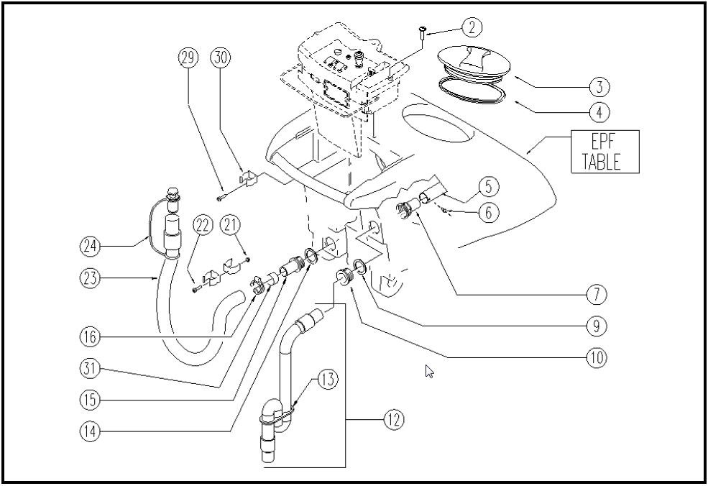

 | ITEM | SKU | DESCRIPTION | QTY
 | 2 | E87877 | Screw WS20/24 FS28/32 | 2
 | 3 | E86518 | Cover | 1
 | 4 | E86503 | Gasket | 1
 | 5 | E87922 | Hose | 1
 | 6 | VTVT00881 | SCREW M4x6 | 1
 | 7 | E89152 | Connector WS20/24 | 1
 | 9 | E87857 | Gasket WS20/24 | 1
 | 10 | E87858 | Suction Opening WS20/24 | 1
 | 12 | E89237 | Squeegee Hose ASM | 1
 | 13 | E86759 | Plaque | 1
 | 14 | E89089 | Gasket | 1
 | 15 | E87772 | Connector for WS20 | 1
 | 16 | E86480 | Double Wire Clamp | 1
 | 21 | VTDD00147 | NUT M 4 | 2
 | 22 | E86734 | Screw | 2
 | 23 | E86522 | Hose | 1
 | 24 | E86993 | Drain hose plug with clamp | 1
 | 29 | E89473 | Screw | 2
 | 30 | E86992 | Hose Clips | 3
 | 31 | E89506 | Drain hose protector WS20 | 1

